Collecting Landing Pages by Source/Medium data

Website/SEO Assignments

NAME: Tahiya Rahman

horizontal line

# About the Data

The purpose of the paper is to find out trends in User Acquisition through all the sources/mediums through the tracking over the Traffic metric over the week time periods of February 5th to February 12th, 2023 in NSTEM. The data will show the potential traffic medium sources provided the user landing pages for the website.

Comparison of Data over time and trends

The data shows that the traffic of top ten landing pages Start a Chapter (Goal 5 Conversion Rate) where the numbers are decent but the conversion rate is not improving except from the two landing pages and their sources.

* Google organic search or the audience who already have the knowledge in the NSTEM website searched the website directly with the site information is in a good shape to gain more traffic. Here are the two materics:

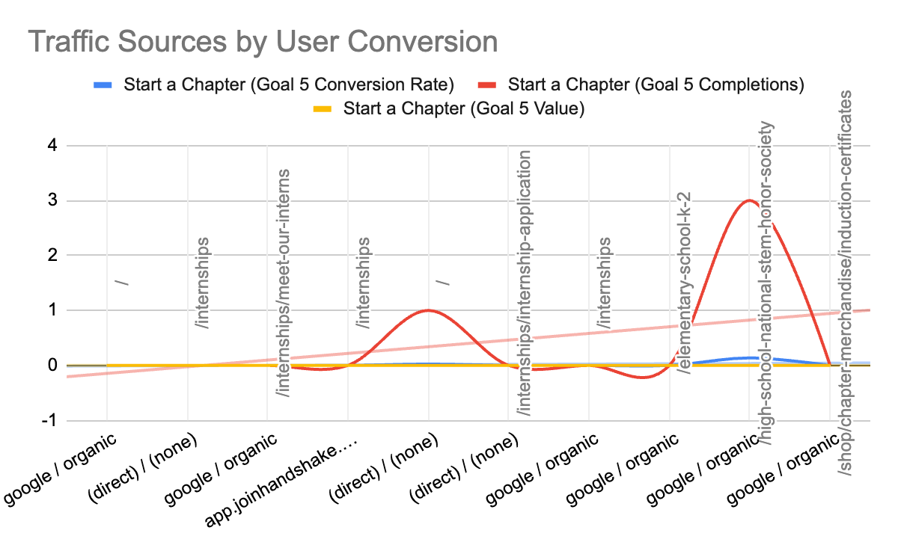

* The Start a Chapter (Goal 5 Completions) showed a correlation with the Start a Chapter (Goal 5 Conversion Rate). Because if the users have created a conversion rate then those users are more likely to start with the Chapters from NTSEM.
* Here are the insights we observed and learned from the overview of traffic on the landing page and its source including data from user acquisition, user behavior and user conversion.

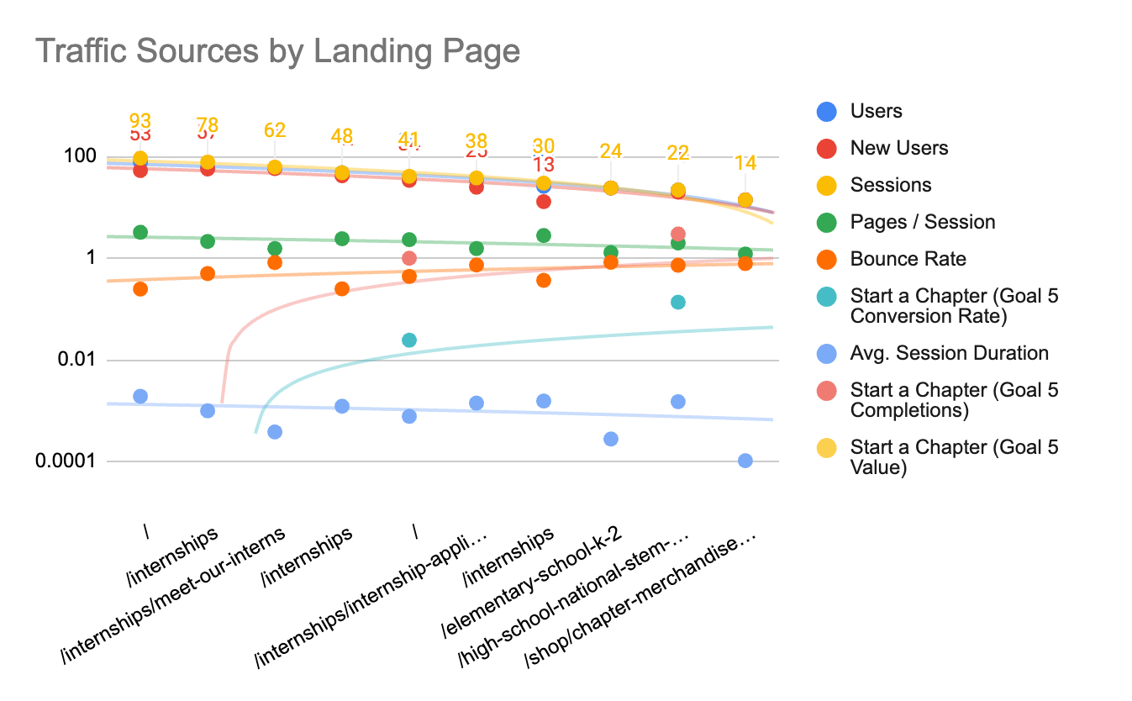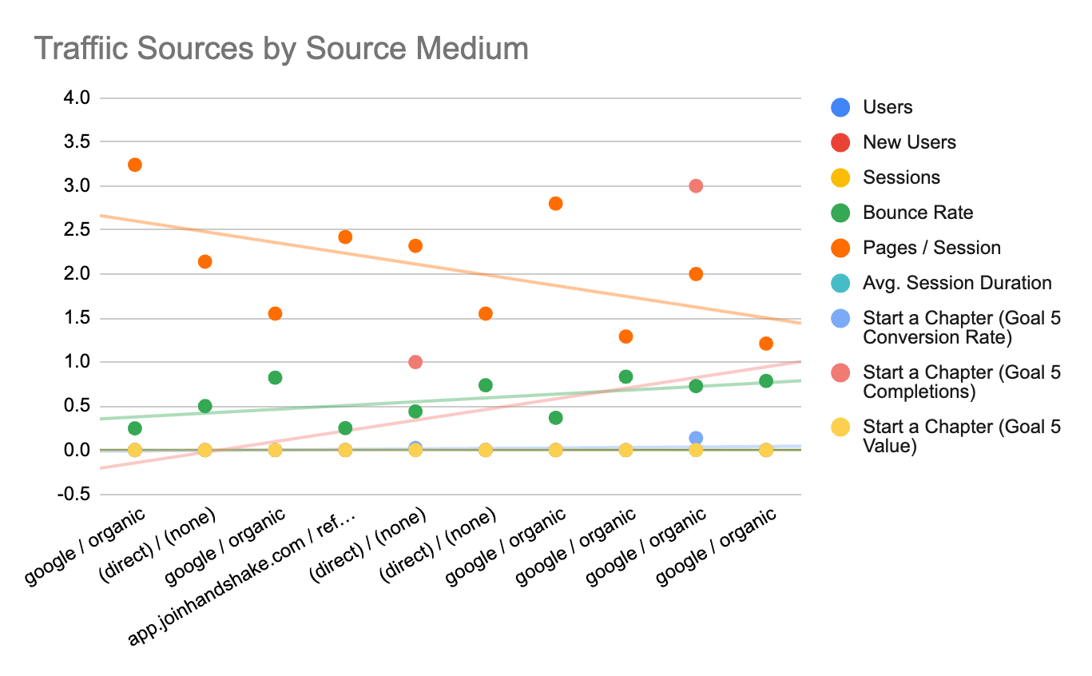

From a side by side visualization:

Conversion:

There are lots of metrics who were included but then excluded from the big picture because it could not pull up any outcome rather a result of zero or sometimes it is behind the zeros. In this case, the data was checked with the percentile and other functions but either way the data collected from the Google Analytics platform showed as valid with the landing page data. So only two conversions are getting a desired outcome where as the Start a Chapter (Goal 5 Value) which is below the threshold and the trendline.

Landing Page & Source/medium:

First Scatter plot, with the 1st line shows the session by the users and it's aligned with the trendline. There are outliers below the trendline in the second visual. The second visual represents the trend in user analytics with the sources such as if it's organic or a direct search from the user.

From a side by side visualization:

User Acquisition & User Behavior:

From the data shown, the sessions for the organic search and the direct searches along with the others sources are all at a good speed to gain the users and new users.

The sessions are in good shape where the peak and the other sessions from the users sources are all showing a positive correlation.

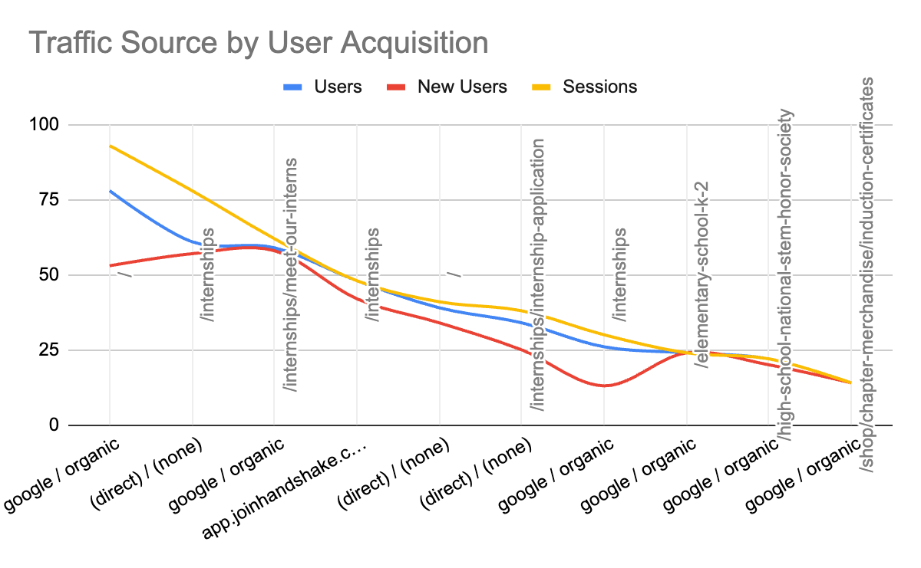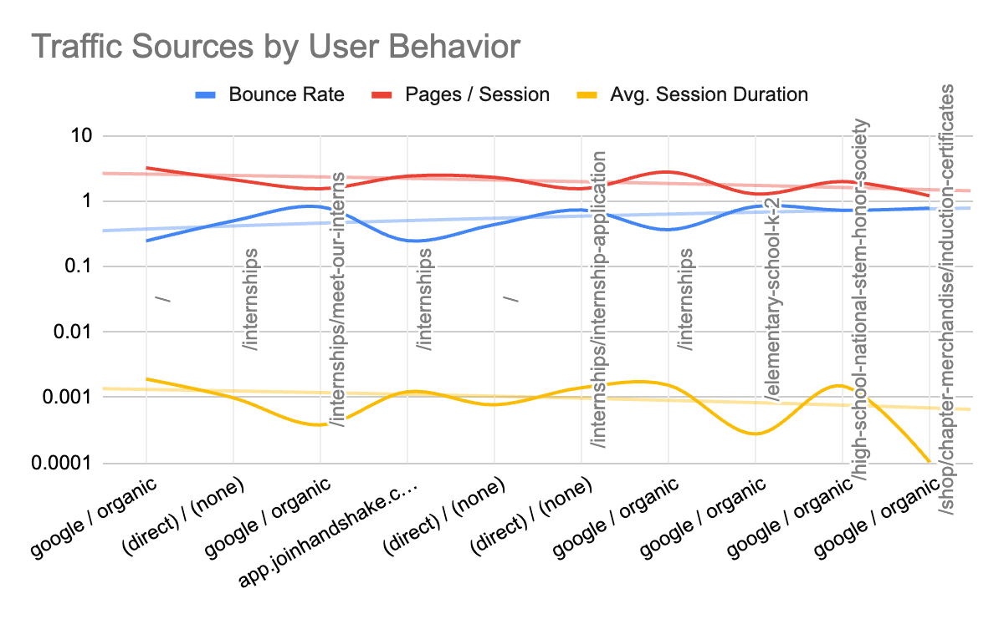

On the other hand, it shows that the user behavior is also in good shape. The average session performance is showing below zero at a scale. But this data can be accepted. Because the average rate has a certain way of calculation where the outcome may not impact the visual. So the page/sessions and the bounce rate shows a positive outcome.

# What NSTEM Should Continue Doing

The improvement is significant from last year to this week. Most importantly to keep the track of the engagement through different mediums.

# Ways to Improve the Website

To understand the students who mostly like to land their searches to /high-school-national-stem-honor-society landing page. But the problem is they are then leaving the website without making any impact. By adding the Google Merchant Store, we will be able to track who the students/parents are leaving the carts, with scroll tracking we will be able to see how many of the students are really interested and scrolling down to the website to better understand and make a decision for purchase.

Data that Stands Out

From the last year to this year there are significant changes as the sessions per page by users and the conversion rate is also heading towards a goal.

# Conclusion

As concluded, the paper now is able to help us to understand the gap analysis and help to find new ways to remarketing those returning users to gain more exposure and create more opportunities for NSTEM.

Google Sheets:

<https://docs.google.com/spreadsheets/d/12_Xiu7zpA42SPKLJ30QEt1-tWnGbFZnznJQCkBJWC5M/edit?usp=sharing>